國立中央大學學生論文比對結果報告書
The Report of National Central University Student Thesis Similarity Check

姓名  Name |  | 系所  Department/Institute |  |  |  | 學號  Student ID
學年度  Academic Year |  | 身份  Program | □碩士班 Master's Program  □碩士在職專班 In-Service Master's Program  □博士班 Doctoral Program
提交版本  Version | □申請學位考試 For the Degree Examination  □畢業離校時繳交系所 For the Department/Institute at Graduation
論文題目
Thesis Title
檢測軟體
Detection Software
檢測日期
Date of Detection
篩選條件  Filter Criteria | 無
相似度比對截圖  Similarity Comparison Screenshot | 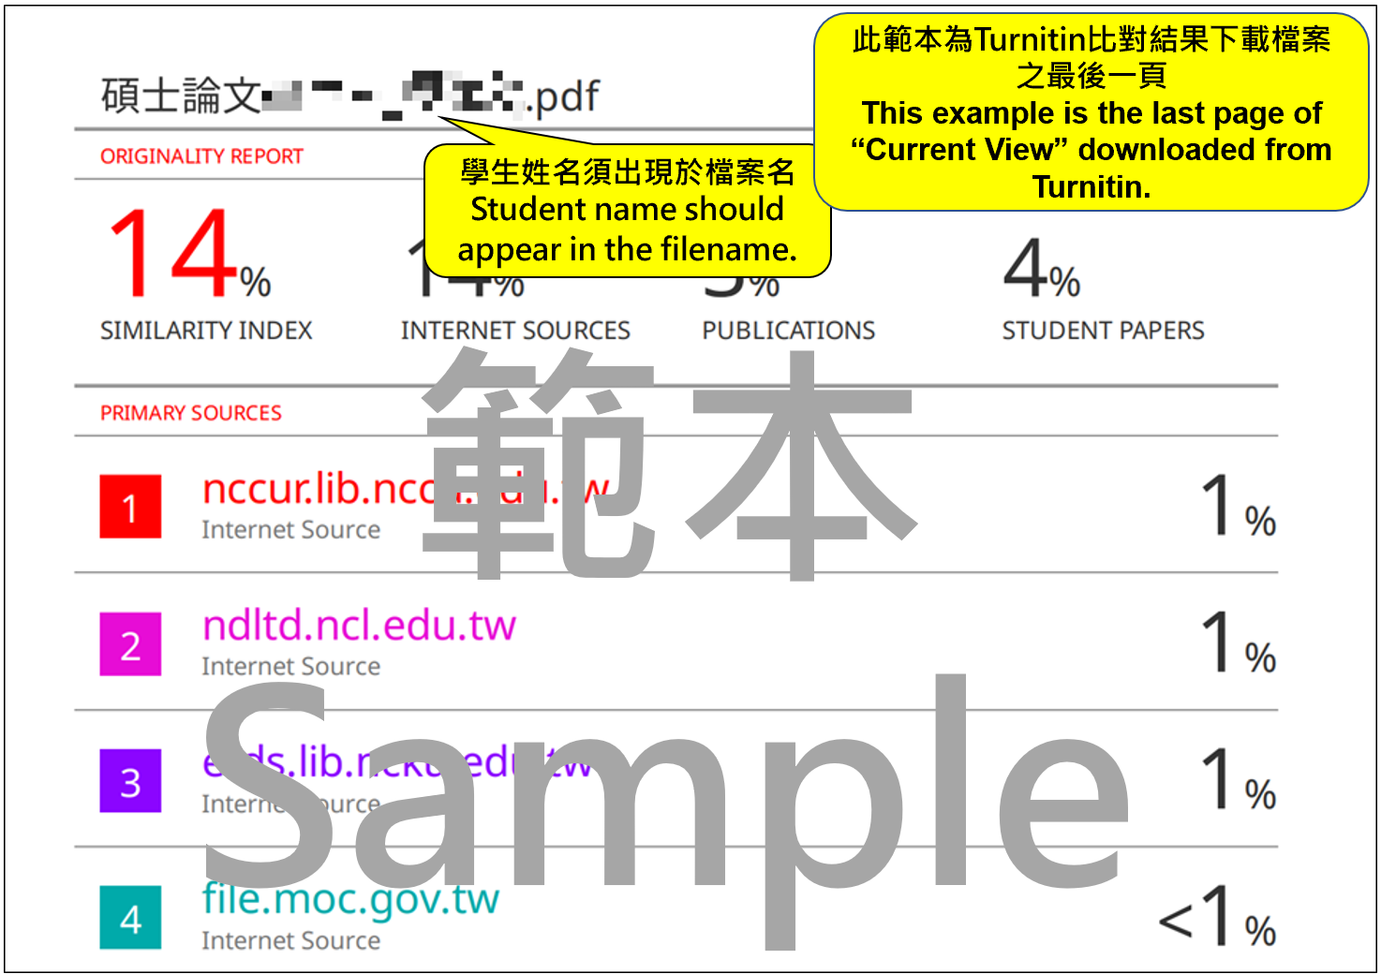
檢附文件Documents Required | 論文相似度比對報告電子回條 (須包含論文封面、作者姓名、檔案名稱、檔案大小、總頁數、上傳日期)  The Digital Receipt or Similarity Report of the Submitted Thesis (Should contain thesis cover page, author, file name, file size, page count, and submission date)
系所規定標準值  Standard Threshold Specified by Department/Institute | 25% |  | 相似度指數  Similarity Index
指導教授簽名  Thesis Advisor's Signature |  |  | 日期  Date
學生簽名  Student's Signature |  |  | 日期  Date
相關條文  Relevant Regulation | 依本校「博士班、碩士班研究生學位考試細則」第五條第二項及第十二條第一項規定辦理  National Central University Regulations on Degree Examinations for Postgraduate Students Article 5, Paragraph 2 and Article 12, Paragraph 1
114.02.24

